FCC AREA 11 ACCOMPLISHMENTS REPORT

2014-2015 FCC Area 11
Family Care Council Area 11 has fulfilled the following goals and accomplishments in our community for the fiscal year 2014-2015.
AOA (monthly meetings, in Miami, Monroe and Broward. Developed a partnership with more than 100 agencies serving the disabled in our communities. Through this partnership we were able to develop the Emergency Management Guide for Disable People through the EM Office of MDC grant 20,000 copies were printed and distributed.

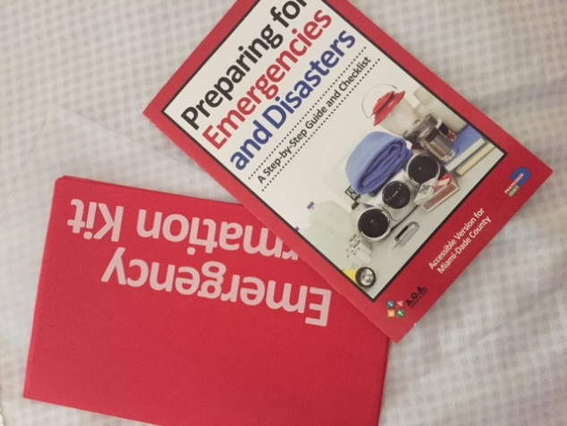

Superintendents=’s District Advisory Panel for Students with Disabilities monthly meeting, ED=education and inclusion subcommittee, Transition subcommittee.

FCIA Family Community Involvement Advisory Council for Miami Dade County Public Schools. Developed the ICare video for improved customer service and sensitivity

Exhibit table at the Miami Dade County Public Schools annual Exceptional Student Education District Conference for families and teachers GIFT Conference.
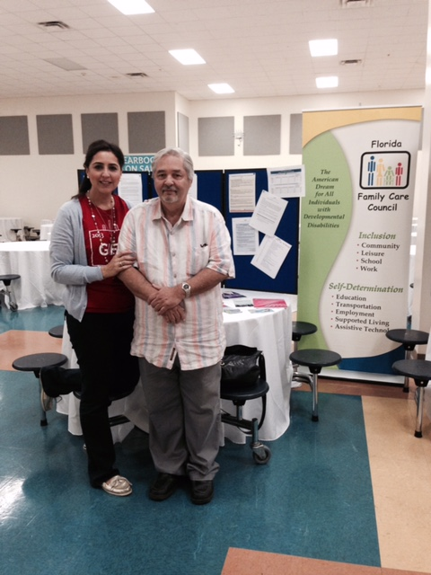

Participated at the annual Superintendent’s Annual Awards Ceremony for Students with Disabilities recognizing from pre-k through employment.

FCCF bi-Monthly meetings participation, MES at the web site sub-committee, FCCF personal stories booklet update, participated in Respite conference.

Family Café State Conference sponsored 3 families to attend the conference to learn about resources in our state.

Participated at the FCCF FL exhibitor table at Family Café

FCC area 11 Social media development of Facebook page Family Care Council Area 11. Important information is distributed via social media through Facebook about meetings, resources in our community, events etc related to disabilities.
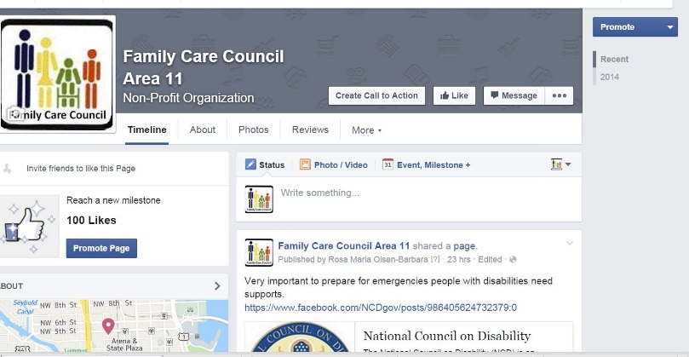

FCC Area 11 New Website www.fccarea11.weebly.com

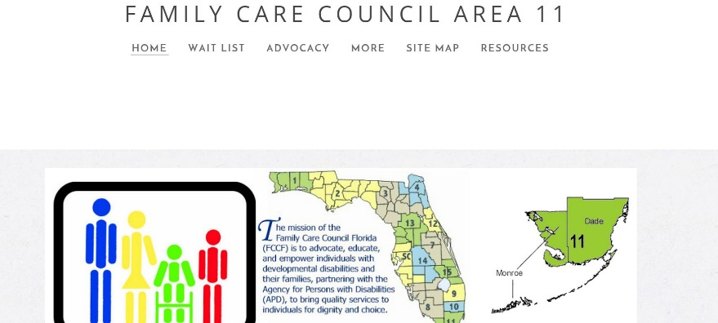

Represented FCC area 11 guest speaker at the Annual Pediatric Medical Doctors Conference, Hawk Cay Key, July 2014.

Participated in the Miami Children’s Hospital Medical Needs and referrals for Individuals with Developmental Disabilities.

Responded to request for intervention by sending letters to our local State Senators and Representatives on Critical Matters Pertaining to the disability community.

FCC members participated at the signing ceremony of the bill of Keep Florida Working with Governor Rick Scott on Monday July, 13 2015 at the Marian Center, Miami Florida.
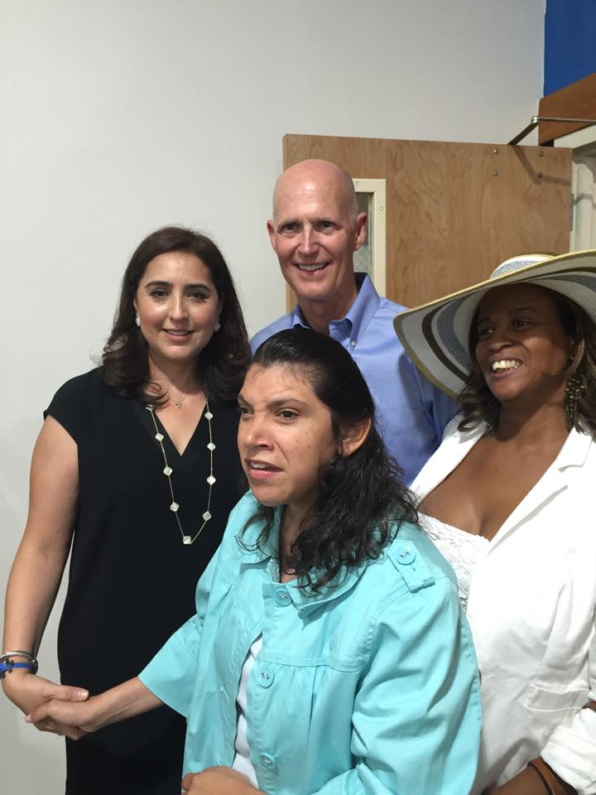

Sponsored the annual Gallery of Dreams Art exhibit at APD.
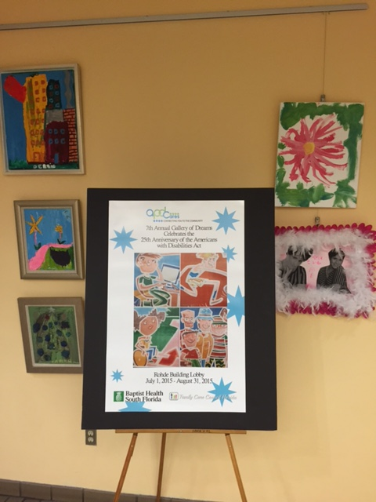
In Addition, the council has met and exceeded the requirements of number of meetings of the local council meetings for the year with a total of 12 meetings.

Respectfully submitted by:
Rosa M. Barbara,
Chair Area 11

